1. Name of the Certificate ¹
Učebný odbor 3473 H 08 polygraph - bookbinder
2. Translated title of the Certificate ²
Polygraf - knihár (sk)
3. Profile of skills and competences
The holder of the certificate is able to:
- choose suitable technological procedures of work in the completion of printed media and in bookbinding production,
- identify and prepare the main and auxiliary materials for the production of everyday bookbinding products,
- optimally determine the work procedure with regard to the use of single-purpose bookbinding production equipment and the material used,
- set up and reconfigure the single-purpose bookbinding devices, which are normally used,
- create bookbinding products and common types of bookbindings according to technological instructions,
- prepare materials for the production of bookbindings or other bookbinding products in the field of book processing,
- prepare, set up and maintain single-purpose bookbinding machines, devices, aids and tools for bookbinding works,
- bind book blocks into leather bindings including the decorations,
- use polygraphic terminology,
- check the operability of the bookbinding machine,
- perform basic input, inter-operational and output controls of raw materials, production materials, semi-finished products and products in bookbinding production,
- assess the quality of bookbinding products on an ongoing basis,
- communicate appropriately with the customer when accepting orders, choose a suitable method of processing and materials with regard to the final bookbinding product,
- observe the principles of safety at work and occupational hygiene,
- apply the principles of environmental protection.

4. Range of occupations accessible to the holder of the certificate ³
The graduate can find employment as a bookbinder in the field of completion of printed media by using available bookbinding techniques, in bookbinding production in work activities for single-purpose bookbinding machines or in work activities in manual bookbinding production.
Examples of possible job positions: bookbinder, paper cutter.

5. Official basis of the certificate
Body awarding the certificate | Authority providing accreditation / recognition of the certificate
Ministry of Education, Science, Research and Sport of the Slovak Republic
Stromová 1
813 30 Bratislava
Phone: +421 2/59 374 111
www.minedu.sk
Level of the certificate (national or European) ¹  Secondary vocational education  SKQF/EQF: 3  ISCED 353 | Grading scale / Pass requirements  1 – excellent  2 – praiseworthy  3 – good  4 – sufficient  5 – insufficient
Access to next level of education / training ¹  Complete secondary vocational education, ISCED 354  University, 1st degree, ISCED 655, 645, 665  University, 2nd degree, ISCED 766, 767 | International agreements on the recognition of qualifications ¹
Legal basis
Act No. 245/2008 Coll. on Education and Training (Education Act) and on amendment of certain acts; Act No. 61/2015 Coll. on Vocational Education and Training and on amendment of certain acts; Decree of the Ministry of Education of the Slovak Republic no. 318/2008 Coll. on the completion of studies at secondary schools, as amended.
6. Officially recognised ways of acquiring the certificate
Successful completion of the four-year training program in the given field of study by passing the final examination.
7. Additional information
After successful completion of the training program in the given field of study the graduates receive a certificate confirming their passing of the final examination and a vocational certificate.
Entry requirements ¹
- lower secondary education, ISCED 244
- fulfilment of prerequisites in the admission procedure
More information (including a description of the national qualifications system)
Ministry of Education, Science, Research and Sport of the Slovak Republic, Study and Training Group
https://www.minedu.sk/18673-sk/studijne-a-ucebne-odbory-sauo/
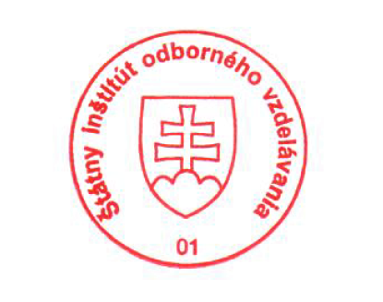 National Europass Centre
State Vocational Education Institute
Bellova 54/a,
837 63 Bratislava
europass@siov.sk
www.europass.sk

