1. Name of the Certificate ¹
Field of study 3473 H 06 polygraph - graphic
2. Translated title of the Certificate ²
Polygraf - grafik (sk)
3. Profile of skills and competences
The holder of the certificate is able to:
- have a grasp on the range of printing materials, know their properties and practical uses,
- know the technical and technological equipment of the polygraphic enterprise and perform the relevant work operations in the field of preparation of the printing form and materials,
- work with production documentation, respect the relevant standards and guidelines of polygraphic production,
- have a grasp of the rules concerning the rates and the methods of their implementation,
- create assembly drawings, assembly plans and assemble individual elements necessary for reproduction,
- reproduce image templates using photomechanical and electronic devices,
- assess the original templates, impressions and previews and perform color corrections,
- correct and edit texts,
- perform checks of page disposals for print sheets,
- use polygraphic terminology,
- use basic densitometer and spectrophotometer measurement techniques,
- work with data for creating printing forms and use equipment necessary for creating printing forms,
- perform basic input, inter-operational and output control of raw materials, production materials, semi-finished products and products in polygraphic production,
- observe the principles of safety at work and occupational hygiene,
- apply the principles of environmental protection.

4. Range of occupations accessible to the holder of the certificate ³
The graduate can find employment as a typesetter, assembler, graphic or operator in the production of printing forms in printing enterprises or graphic studios. The graduate can also find employment in advertising agencies and graphic studios in the processing of materials and templates for the production of printed media.
Examples of possible job positions: typesetter, graphic, assembler, operator in the production of printing forms.

5. Official basis of the certificate
Body awarding the certificate | Authority providing accreditation / recognition of the certificate
Ministry of Education, Science, Research and Sport of the Slovak Republic
Stromová 1
813 30 Bratislava
Phone: +421 2/59 374 111
www.minedu.sk
Level of the certificate (national or European) ¹  Secondary vocational education  SKQF/EQF: 3  ISCED 353 | Grading scale / Pass requirements  1 – excellent  2 – praiseworthy  3 – good  4 – sufficient  5 – insufficient
Access to next level of education / training ¹  Complete secondary vocational education, ISCED 354  University, 1st degree, ISCED 655, 645, 665  University, 2nd degree, ISCED 766, 767 | International agreements on the recognition of qualifications ¹
Legal basis
Act No. 245/2008 Coll. on Education and Training (Education Act) and on amendment of certain acts; Act No. 61/2015 Coll. on Vocational Education and Training and on amendment of certain acts; Decree of the Ministry of Education of the Slovak Republic no. 318/2008 Coll. on the completion of studies at secondary schools, as amended.
6. Officially recognised ways of acquiring the certificate
Successful completion of the three-year training program in the given field of study by passing the final examination.
7. Additional information
After successful completion of the training program in the given field of study the graduates receive a certificate confirming their passing of the final examination and a vocational certificate.
Entry requirements ¹
- lower secondary education, ISCED 244
- fulfilment of prerequisites in the admission procedure
More information (including a description of the national qualifications system)
Ministry of Education, Science, Research and Sport of the Slovak Republic, Study and Training Group
https://www.minedu.sk/18673-sk/studijne-a-ucebne-odbory-sauo/
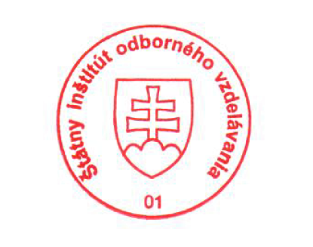 National Europass Centre
State Vocational Education Institute
Bellova 54/a,
837 63 Bratislava
europass@siov.sk
www.europass.sk

